**Prerequisite**

**EC2 windows instance**

* **How to launch EC2 windows instance please refer the below link**
* <https://docs.aws.amazon.com/AWSEC2/latest/WindowsGuide/EC2_GetStarted.html>

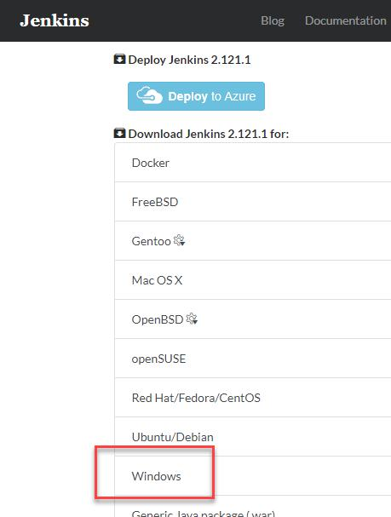**Step 1)** Got to <https://jenkins.io/download/> and select the platform. In our case Windows

**Step 2)** Go to download location from local computer and unzip the downloaded package. Double-click on unzipped **jenkins.msi**

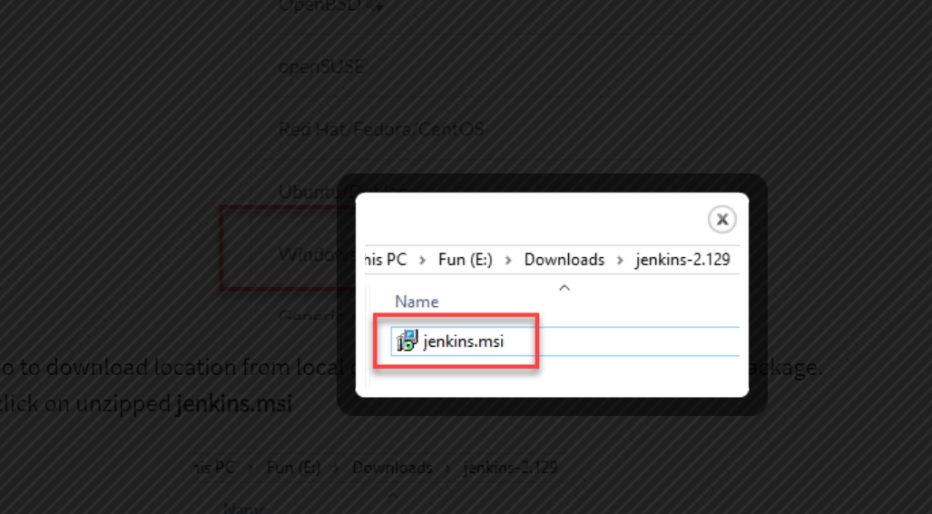

**Step 3)** In the setup screen, click Next.

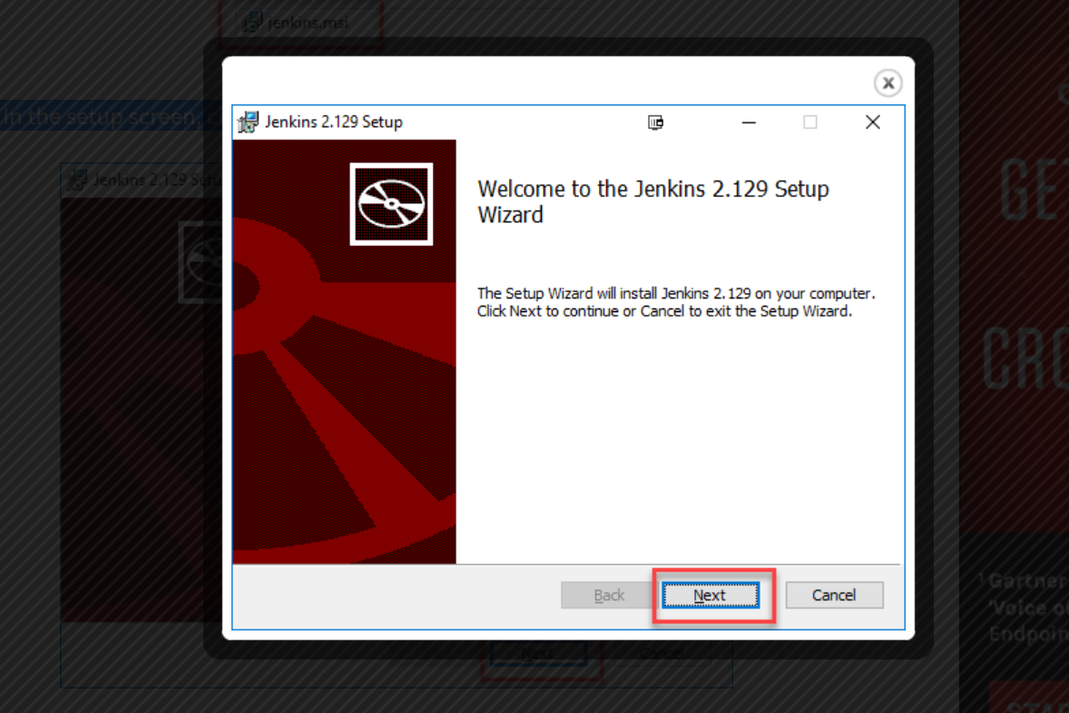

**Step 4)** Choose the location where you want to have the Jenkins instance installed (default location is C:\Program Files (x86)\Jenkins), then click on **Next** button.

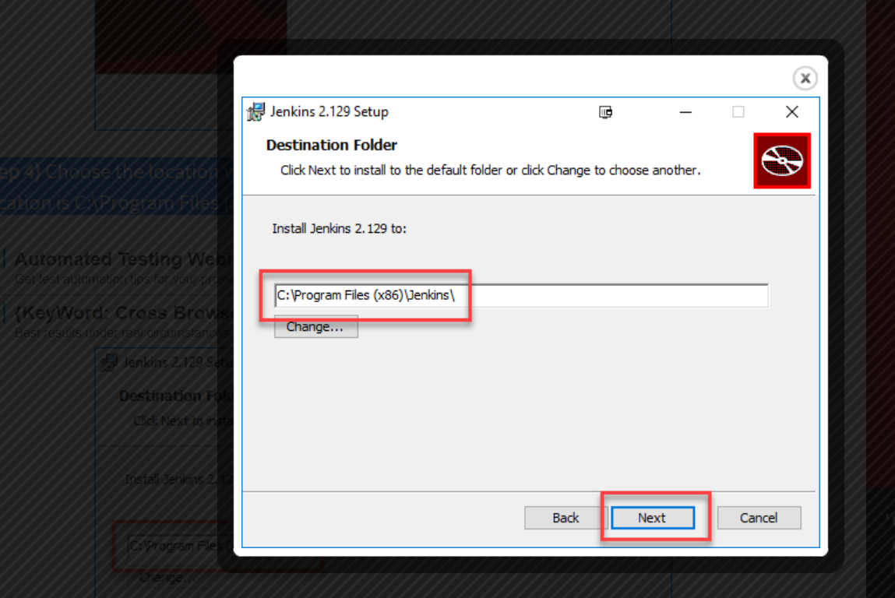

**Step 5)**Click on the Install button

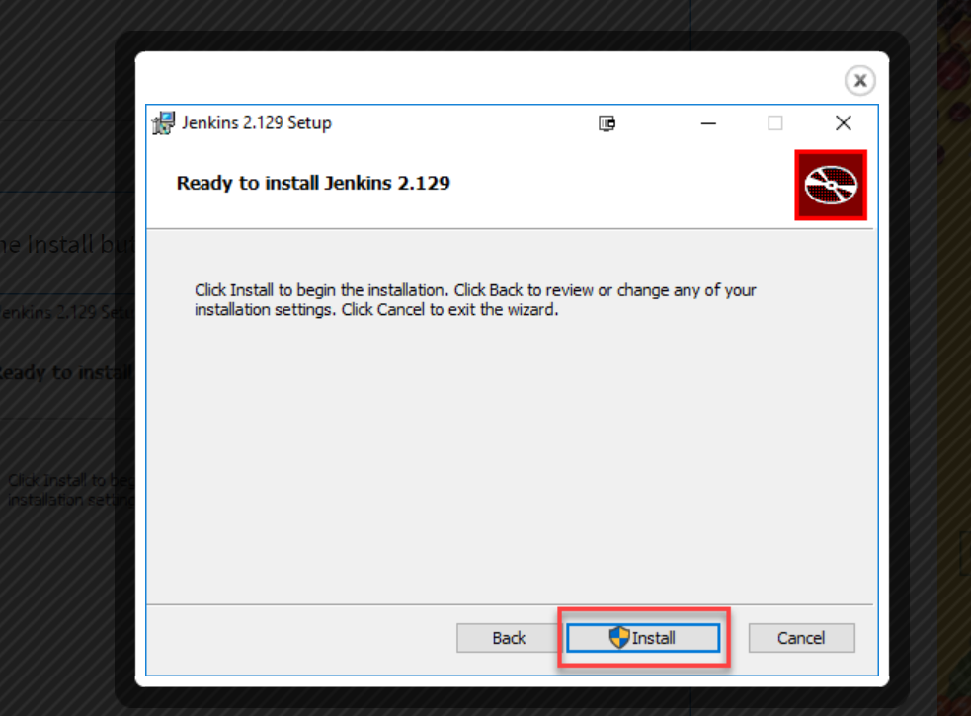

**Step 6)** Once install is complete, click Finish.

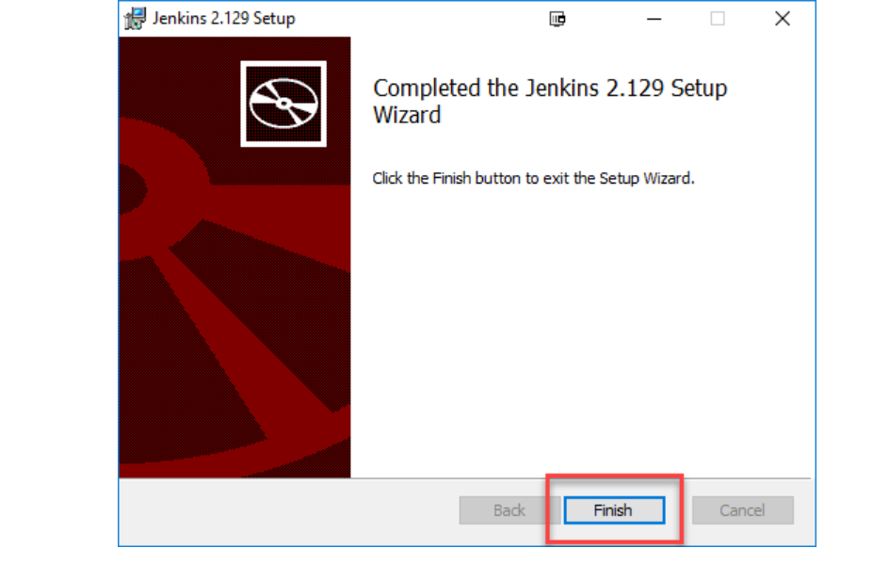

**Step 7)** During the installation process an info panel may pop-up to inform the user that for a complete setup, the system should be rebooted at the end of the current installation. Click on OK button when the Info panel is popping-up:

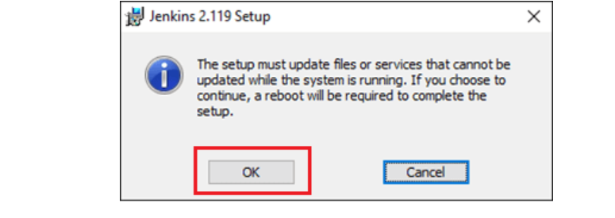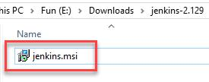

## How to Unblock Jenkins

**Step 1)** After completing the Jenkins installation process, a browser tab will pop-up asking for the initial Administrator password. To access Jenkins, you need to go to browse the following path in your web browser.

http://localhost:8080

If you can access the above URL, then it confirms that Jenkins is successfully installed in your system.

## 

**Step 2)** The initial Administrator password should be found under the Jenkins installation path (set at Step 4 in Jenkins Installation).

For default installation location to C:\Program Files (x86)\Jenkins, a file called **initialAdminPassword** can be found under C:\Program Files (x86)\Jenkins\secrets.

However, If a custom path for Jenkins installation was selected, then you should check that location for **initialAdminPassword**file.

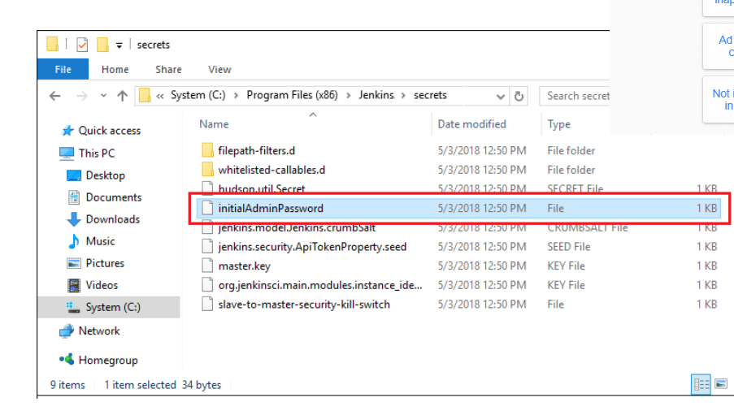

**Step 3)** Open the highlighted file and copy the content of the **initialAdminPassword**file.

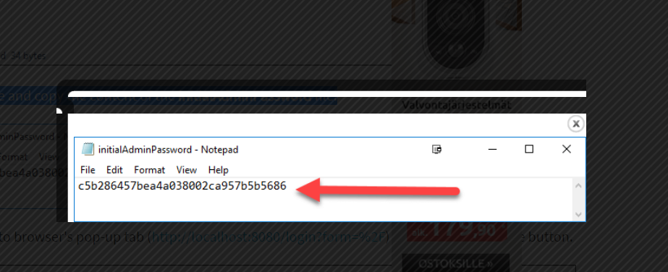

**Step 4)** Paste the password it into browser's pop-up tab (<http://localhost:8080/login?form=%2F>) and click on Continue button.

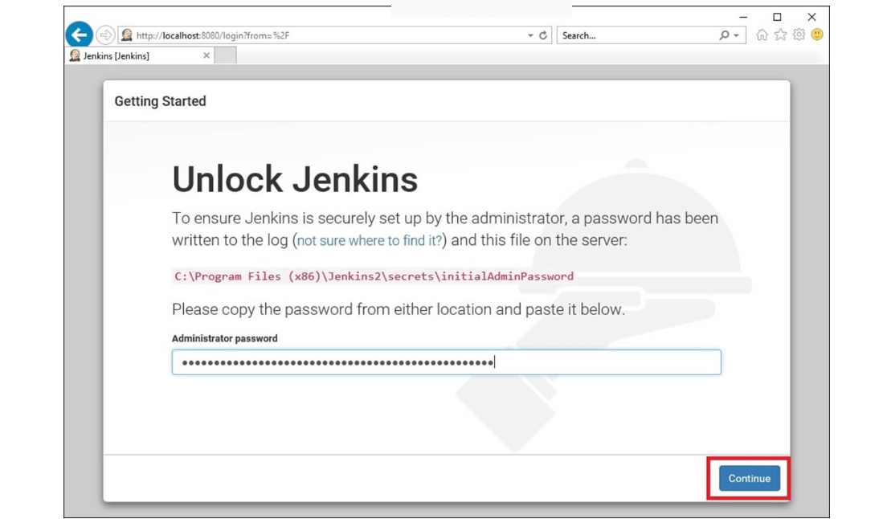

## **Step 5)** Click on the "Install suggested plugins button" so Jenkins will retrieve and install the essential plugins

## 

Jenkins will start to download and install all the necessary plugins needed to create new Jenkins Jobs.

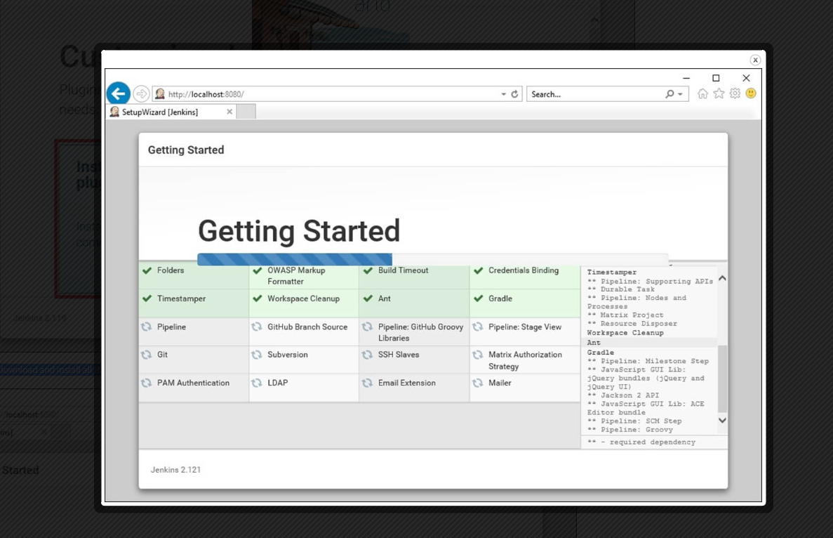

**Note**: You can choose the Option "Select Plugins to Install" and select the plugins you want to install

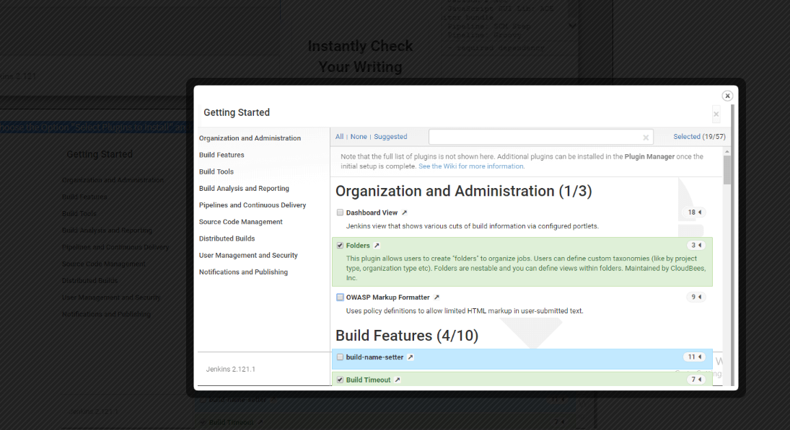

**Step 6** After all suggested plugins were installed, the "Create First Admin User" panel will show up. Fill all the fields with desired account details and hit the "**Save and Finish**" button.

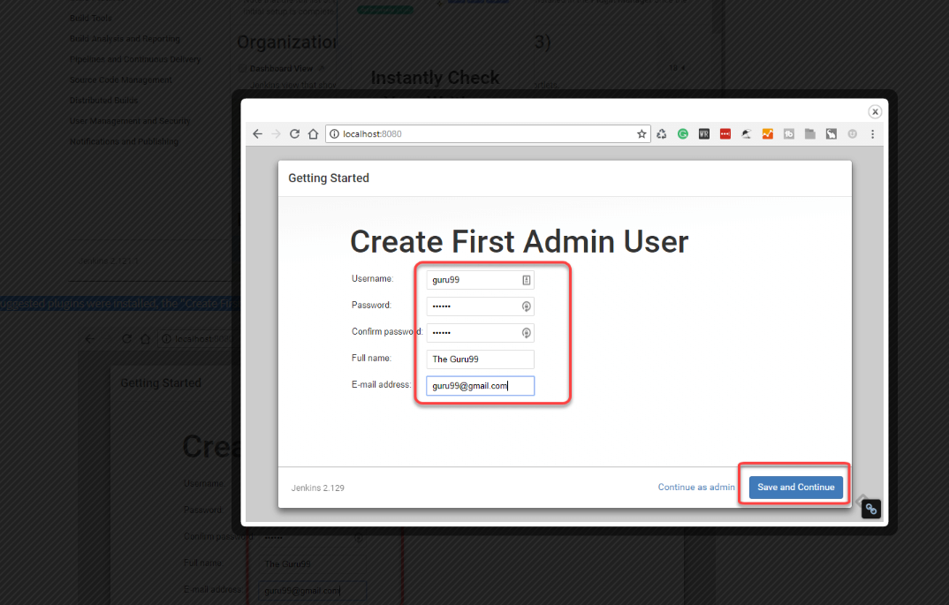

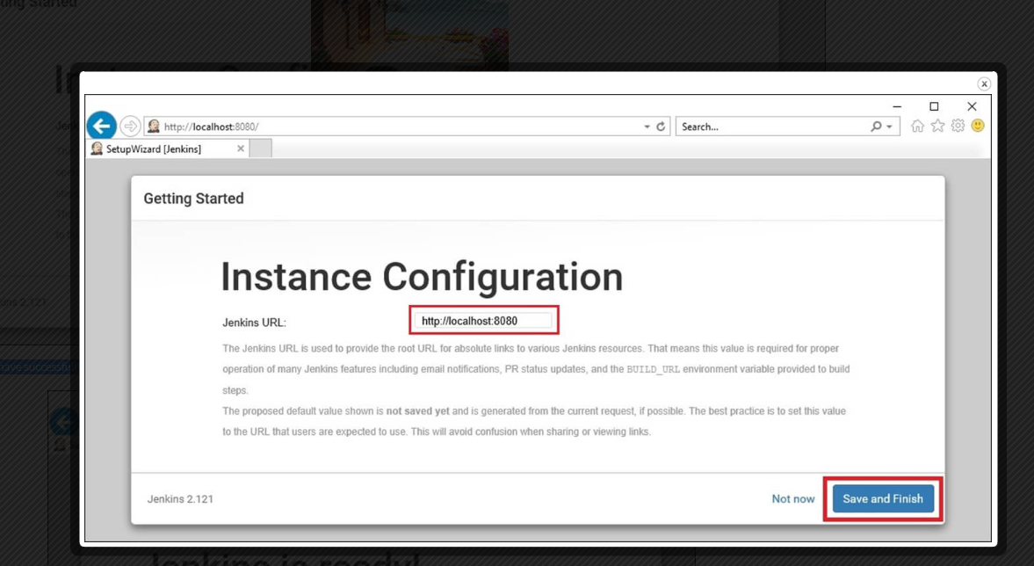

Step 7 ) Hit the "**Save and Continue**" button:

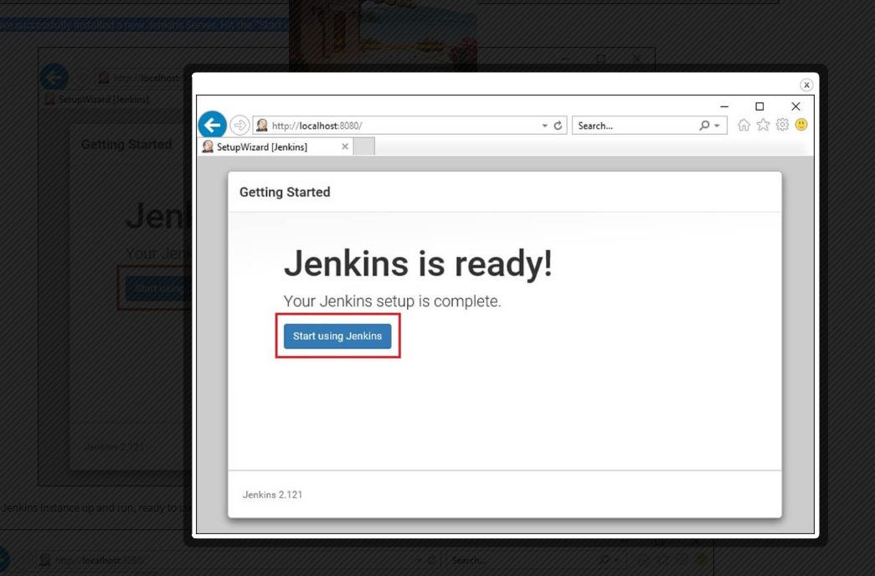

**Changing the Jenkins port from 8080**:-

* Go to the directory where you installed the Jenkins (By default, it is under Program Files/Jenkins
* Open the Jenkins.xml from the Jenkins directory.
* Search “**–httpPort=8080**” and replace the “**8080**” with the new port number that you wish. (i.e. 8282)
* Save and exit the file and restart the Jenkins with the new URL. [**http://localhost:8282/**](http://localhost:8282/)
* If you have downloaded the war file instead of installation, you can also change the port by running the war file in command/terminal as below.

|  |  |
| --- | --- |
| * 1 | java -jar jenkins.war --httpPort=8282 |

* **Note**: If your Jenkins isn’t started in registered new port, you might need to restart the Jenkins service as well.

## Creating Job

## **Step 1)**To create a Jenkins freestyle job, log on to your Jenkins dashboard by visiting your Jenkins installation path. Usually, it will be hosted on localhost at [http://localhost:8080](http://localhost:8080/) If you have installed Jenkins in another path, use the appropriate URL to access your dashboard.

## 

**Step 2)**Click on "**New Item**" at the top left-hand side of your dashboard.

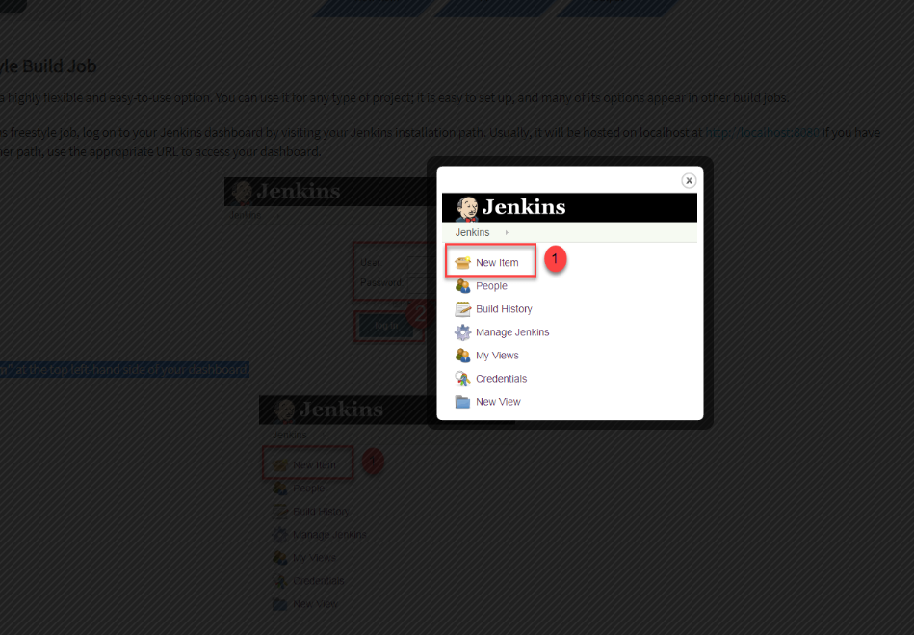

Step 3) In the next screen,

1. Enter the name of the item you want to create. We shall use the "Hello world" for this demo.
2. Select Freestyle project
3. Click Okay

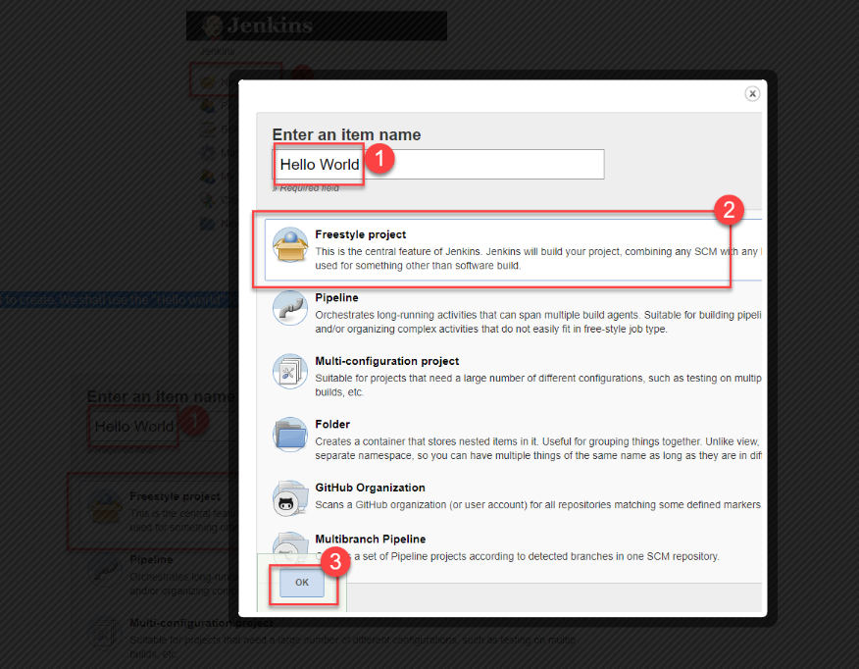

**Step 4)**Enter the details of the project you want to test.

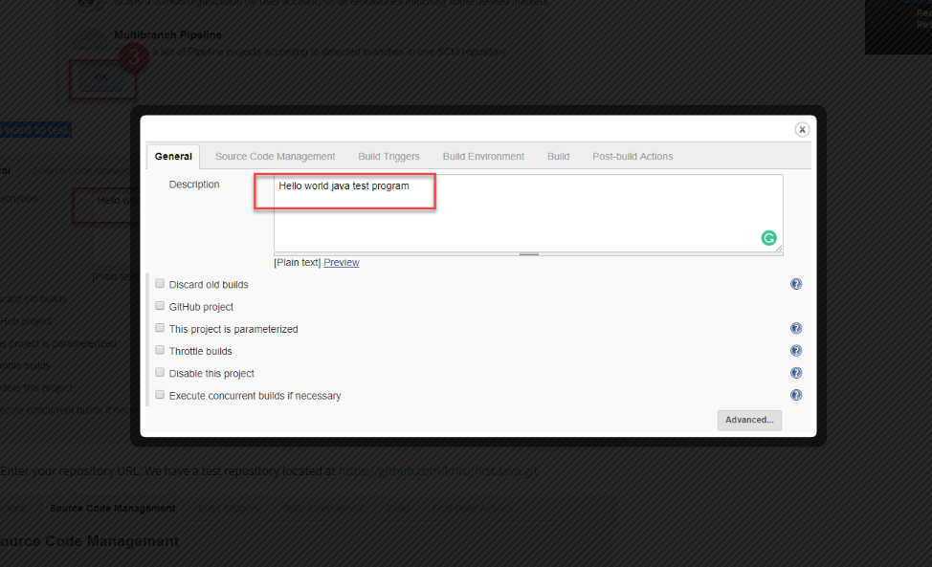

**Step 5)**Under Source Code Management, Enter your repository URL.

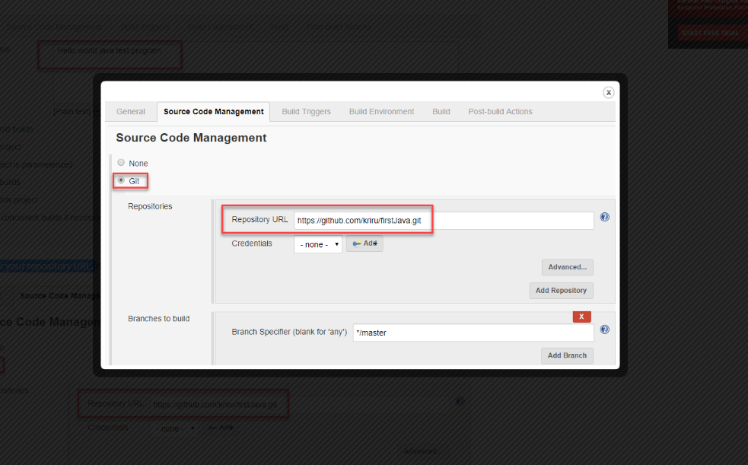

**Step 6)**Now that you have provided all the details, it's time to build the code. Tweak the settings under the **build** section to build the code at the time you want. You can even schedule the build to happen periodically, at set times.

Under **build**,

* Click on "**Add build step**"
* Click on "**Execute Windows batch command**" and add the commands you want to execute during the build process.

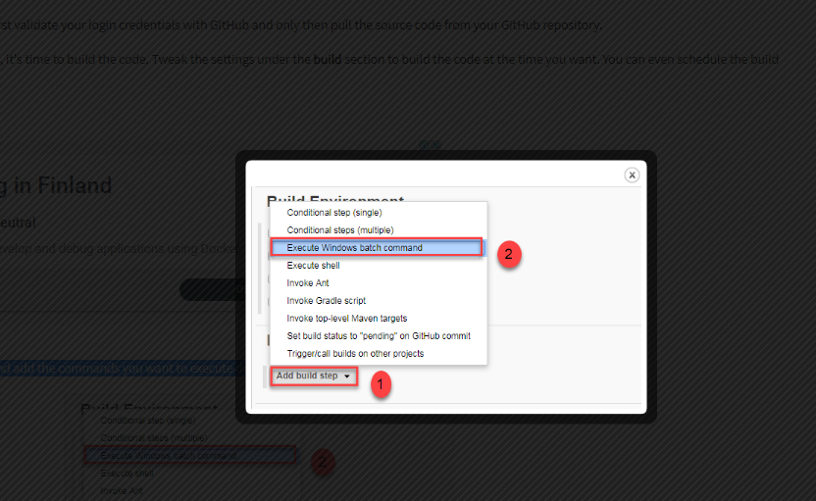

* Here, I have added the java commands to compile the java code.
* I have added the following windows commands:
* javac HelloWorld.java
* java HelloWorld

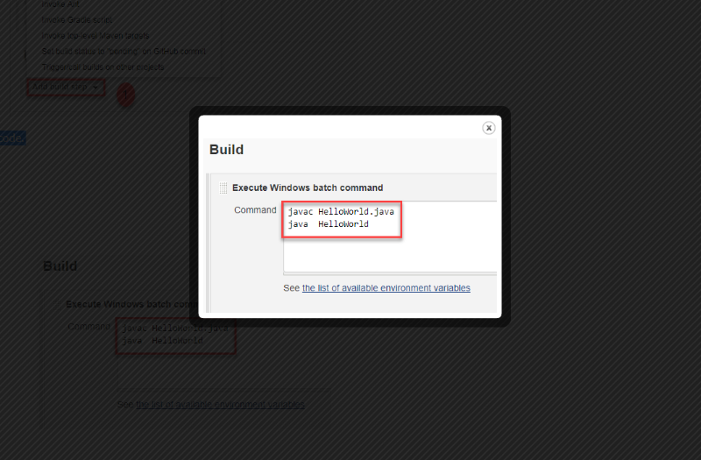

Step 7) When you have entered all the data,

1. Click Apply
2. Save the project.

Step 8) Now, in the main screen, Click the Build Now button on the left-hand side to build the source code.

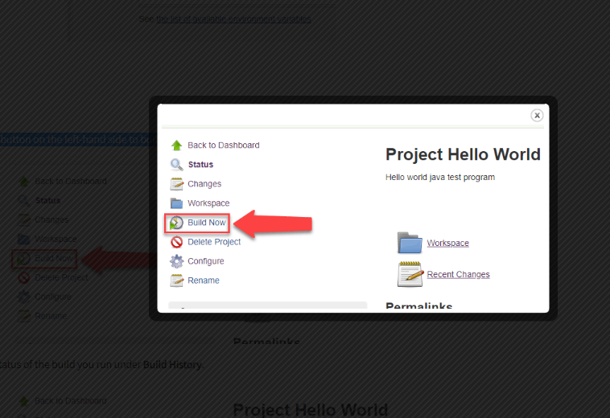

**Step 9)**After clicking on **Build now,**you can see the status of the build you run under **Build History**.

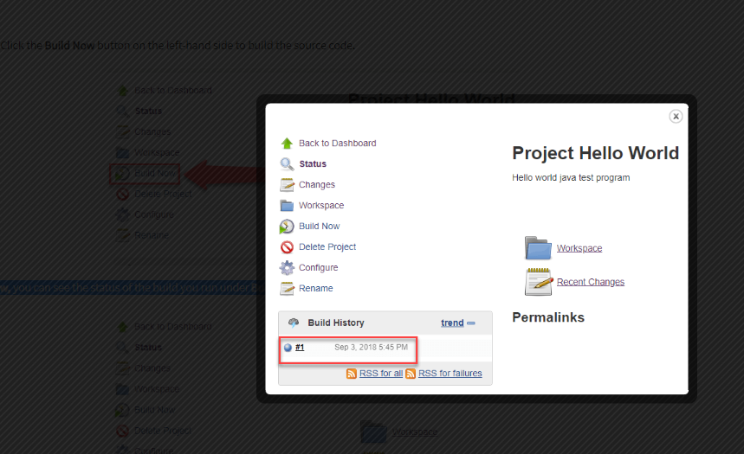

**Step 10)**Click on the **build number**andthenClick on **console output**to see the status of the build you run. It should show you a success message, provided you have followed the setup properly.

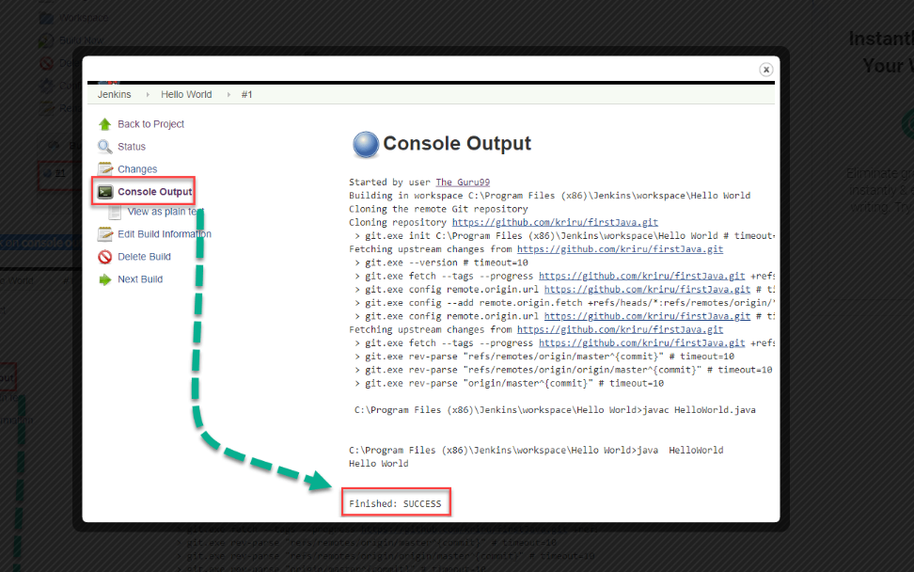

# **How to Create Users & Manage Permissions: Role Strategy Plugin**

**Step 1)**Login to your Jenkins dashboard by visiting <http://localhost:8080/>

If you haven't installed Jenkins in your local server, go to the appropriate URL and access your dashboard by using your login credentials.

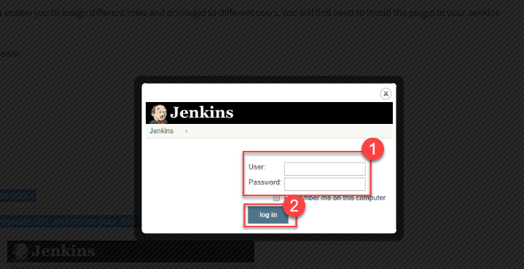

Step 2) You will now see options to create new users and manage current users.

Step 3) Create User

* Under Manage Jenkins, Click Create User
* Enter User details like password, name, email etc.
* Click Create User

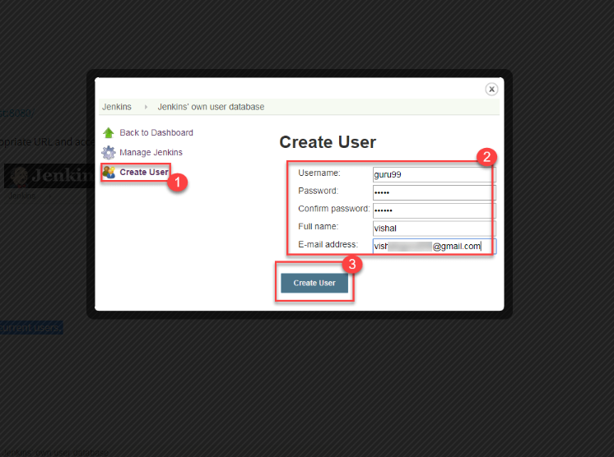

**Step 4)**User is created

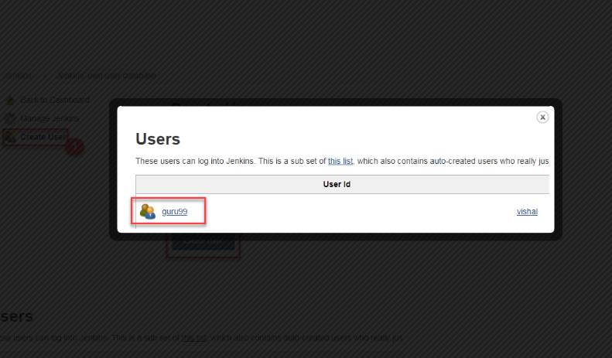

## Install Role Strategy Plugin

There are two methods for installing plugins in Jenkins:

1. Installing it through your Jenkins dashboard
2. Downloading the plugin from Jenkins website and installing it manually

**Step 1)**

1. Go to **Manage Jenkins**
2. Click on the Manage Plugins option

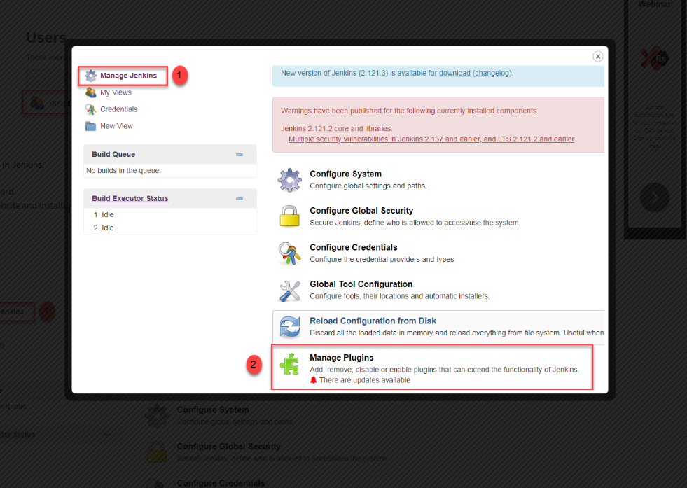

Step 2)

1. In available section, screen Search for "role".
2. Select Role-based Authorization Strategy plugin
3. Click on "Install without restart" (make sure you have an active internet connection)

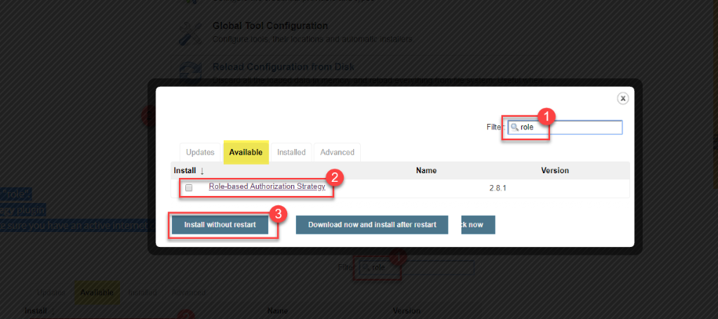

Step 3) Once the plugin is installed, a "success" status will be displayed.

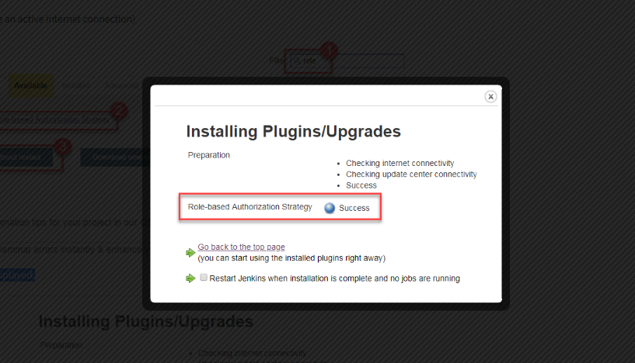

Click on **Go back to the top page.**

**Step 4)**Go to **Manage Jenkins ->**Configure Global Security -> Under **Authorization,**select **Role Based Strategy**.Click on**Save**.

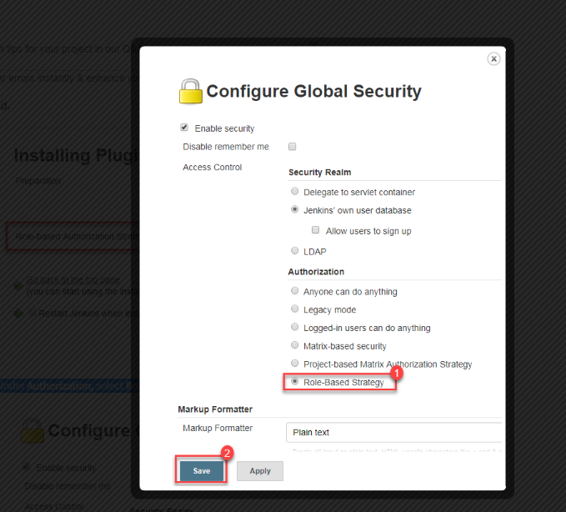

## Create Roles

**Step 1)**

1. Go to **Manage Jenkins**

2. Select **Manage and Assign Roles**

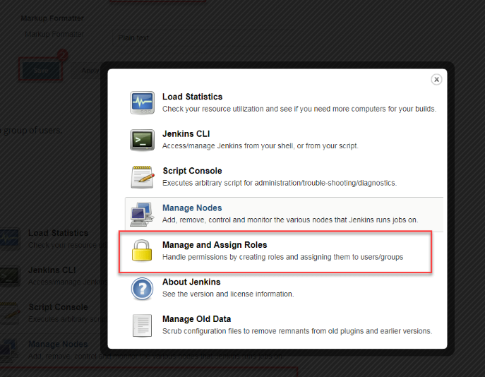

**Note:**that the **Manage and Assign Roles**option will only be visible if you've installed the role strategy plugin.

**Step 2)**Click on **Manage Roles**to add new roles based on your organization.

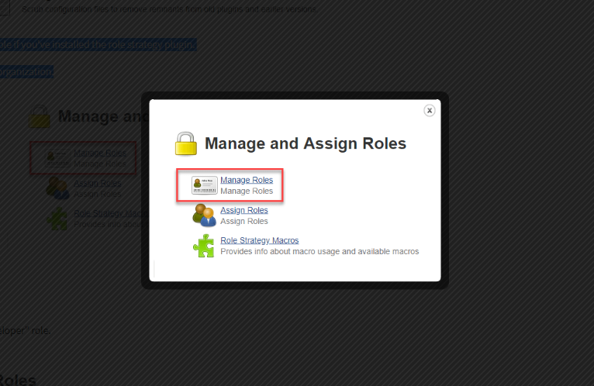

Step 3) To create a new role called "developer",

1. Type "developer" under "role".
2. Click on "Add" to create a new role.
3. Now, select the permissions you want to assign to the "Developer" role.
4. Click Save

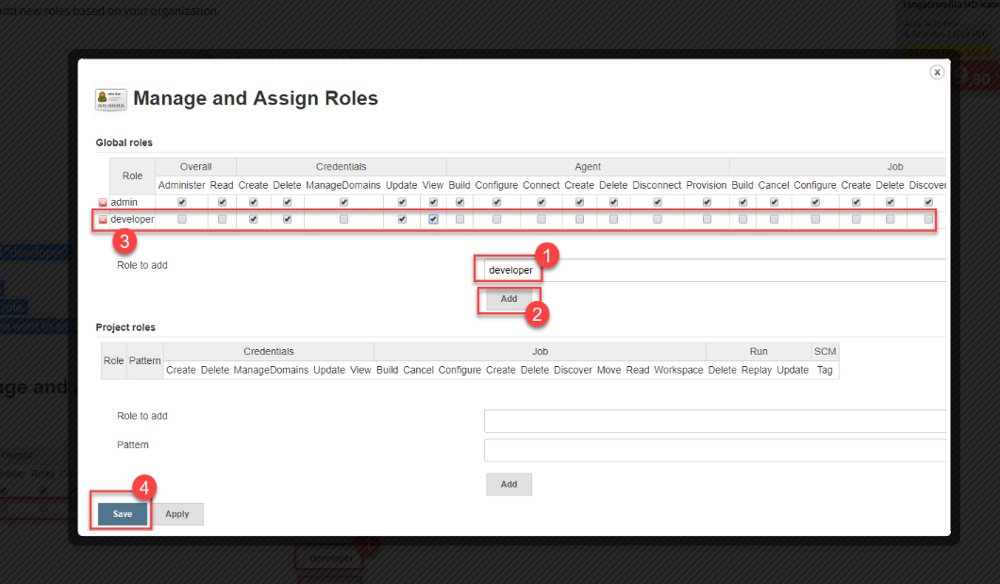

## Assign a Role

**Step 1)**Now that you have created roles, let us assign them to specific users.

* Go to **Manage Jenkins**
* Select Manage and Assign Roles

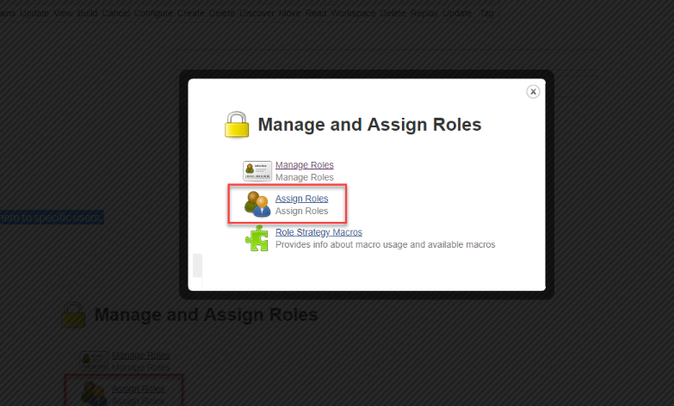

Step 2) We shall add the new role "developer" to user "guru99"

* Selector developer role checkbox
* Click Save

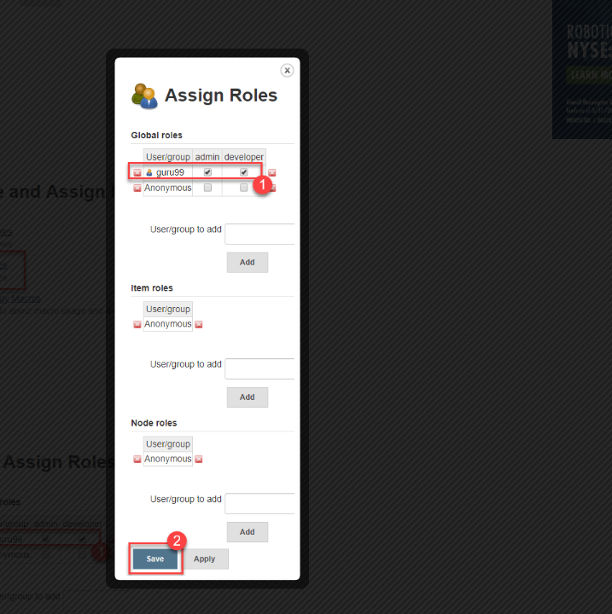

## Project Roles:-

You can create project specific roles under **Project Roles.**

**Step 1)**In Jenkin's Manage and Assign Roles

1. Enter a role as "tester"
2. Add a pattern to this by adding **tester.\***, so that any Project starting with "Project" will be assigned the project role you specify.
3. Click Add
4. Select privileges
5. Click Save

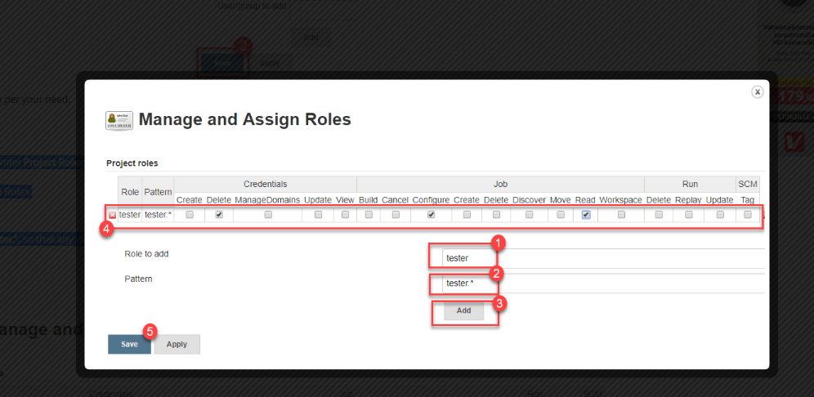

**Assign project role to user**

Step 1:- click on Global configuration under Manage Jenkins.

Step 2:- click on radio button "Role-Based Strategy" and save.

Step 3:- Go to Manage and Assign Roles under Manage Jenkins.

Step 4:- select Manage Roles.

Step 5 :- Add user in particular project

Step 5:- You will see somewhat similar image as

